**Technical architecture :**

Project Design Phase-II Technology Stack (Architecture & Stack)

|  |  |
| --- | --- |
| Date | 03 October 2022 |
| Team ID | PNT2022TMID15415 |
| Project Name | News Tracker Application |
| Maximum Marks | 4 Marks |

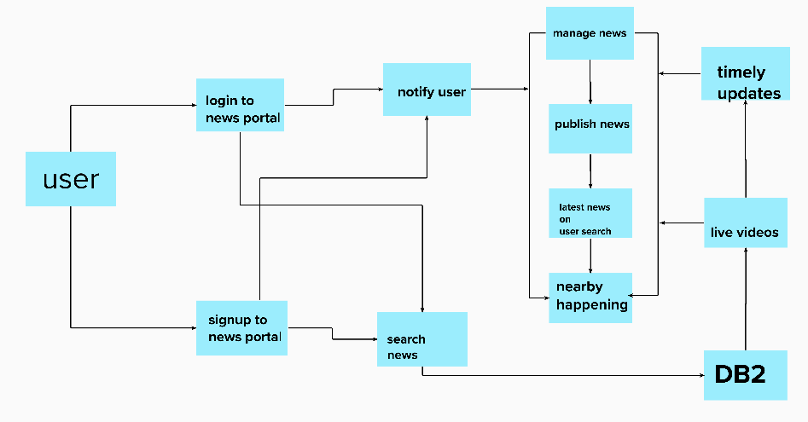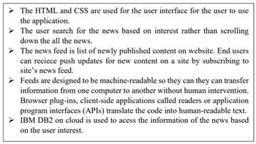

**Table-1 : Components & Technologies:**

|  |  |  |  |
| --- | --- | --- | --- |
| **S. No** | **Component** | **Description** | **Technology** |
| 1. | User Interface | User interacts with the application using web development, which is used to get the information needed for the user. | HTML, CSS, JavaScript / React Js etc. |
| 2. | Application Logic | The Logic depends on the extraction news from the database | Python |
| 3. | Database | Data type , configuration etc. | MYSQL, NOSQL, etc. |
| 4. | Cloud database | Database service on cloud | IBM DB2, IBM Cloudnet etc.. |
| 5. | File storage | File storage requirements | IBM Block Storage or Other Storage Service or Local Filesystem. |
| 6. | Infrastructure ( server/cloud) | Application deployment on local system / cloud local server configuration : Docker  Cloud server configuration : Kubernetes | Local, Cloud Foundry, Kubernetes, etc. |
| 7. | File Storage | File storage requirements | IBM Block Storage or Other Storage Service or Local Filesystem |
| 8. | External API-1 | Purpose of External API used in the application | IBM Weather API, etc. |
| 9. | External API-2 | Purpose of External API used in the application | Aadhar API, etc. |
| 10. | Machine Learning Model | Purpose of Machine Learning Model | Object Recognition Model, etc. |
| 11. | Infrastructure (Server / Cloud) | Application Deployment on Local System / Cloud Local Server Configuration:  Cloud Server Configuration : | Local, Cloud Foundry, Kubernetes, etc. |

Table-2 : Application Characteristics:

|  |  |  |  |
| --- | --- | --- | --- |
| **S. No** | **Characteristics** | **Description** | **Technology** |
| 1. | Open-Source Frameworks | A software for which the original source code is made freely available and may be redistributed and modified according to the requirement of the  user | Python |
| 2. | Security Implementations | Cloud Security Posture Management(CSPM), Detect cloud security and compliance configuration risk, anomalous activity, vulnerabilities, and misconfigurations. | Built – in encryption , BYOK |
| 3. | Scalable Architecture | Python is one of the pioneers of programming languages that developers can use to do all the scaling work. To improve scalability, you can enable or disable services run by the dispatcher on individual servers to balance the load for a given computer by request type . | Technology used in the architecture is that with the Python and the IBM cloud. |
| 4. | Availability | Availability is the ability of a system to withstand or recover from exceptional situations, such as a computer failure. IBM Cloud is on-demand access, via the internet, to computing resources applications, servers (physical servers and virtual servers), data storage, development tools, networking capabilities, and more hosted at a remote data centre managed by a cloud services  provider (or CSP). | Technology used are the IBM cloud and the database. |
| 5. | Performance | DB2 is a database product from IBM. It is a Relational Database Management System (RDBMS). DB2 is designed to store, analyse and retrieve the data efficiently. DB2 product is | Technology used are the python, cloud and IBM db2 |

|  |  |  |  |
| --- | --- | --- | --- |
|  |  | extended with the support of Object-Oriented features and non-relational structures with XML. |  |